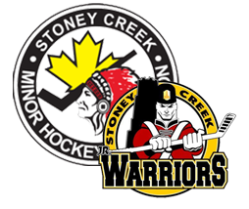
BECOME A SPONSOR AND GET YOUR COMPANY NOTICED!!!

SCMHA is looking for local companies interested in sponsoring our: 2018 Rep Tryout Jerseys

For more information contact: Andrew Cote – Director of Purchasing & Equipment andrewcote@scmha.ca

Deadline: March 14th, 2018
Sponsor name will appear on the back of Tryout jerseys